**AI-Based Diabetes Prediction System**

**211521243058:**

**M.J GURU VENKATESH  
 Phase-2: Innovation**

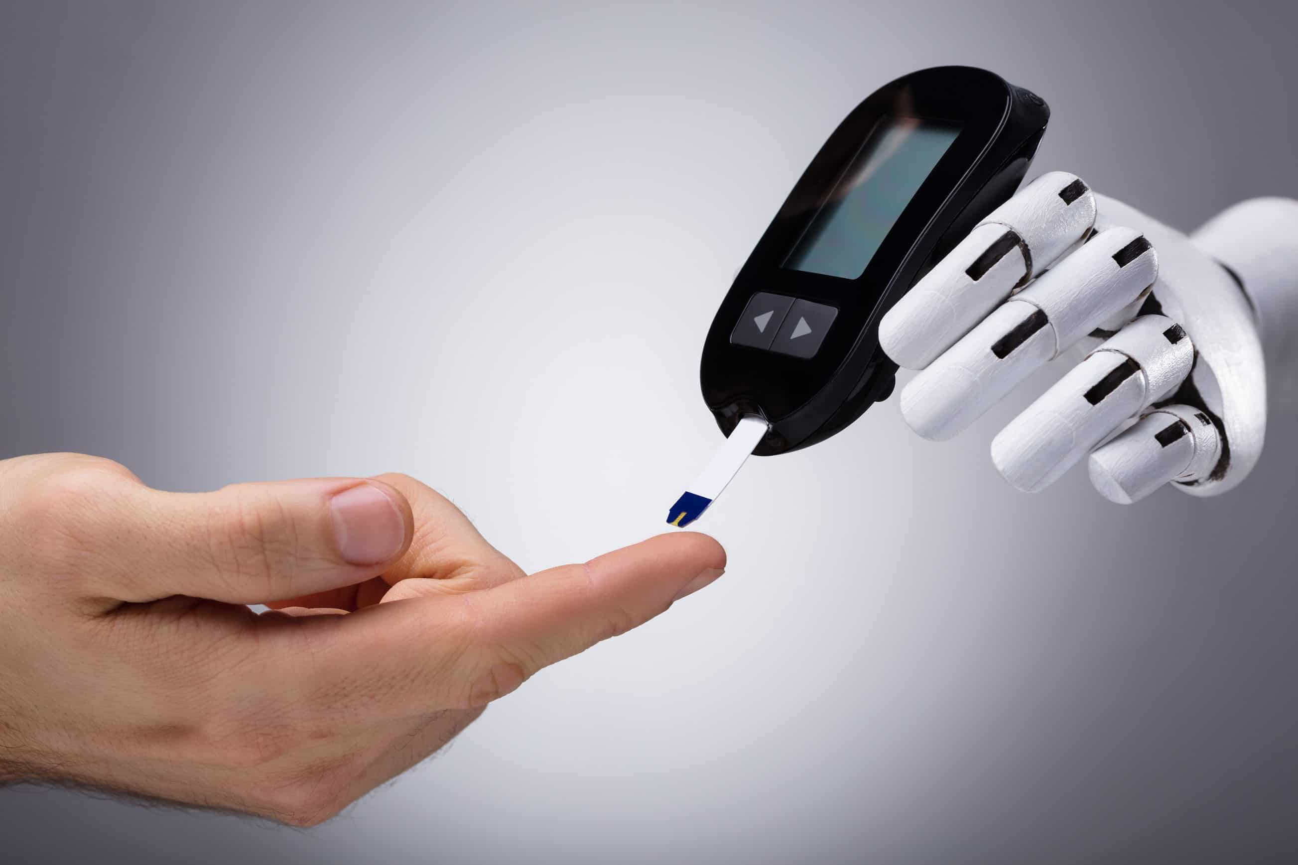

Creating an AI-based diabetes prediction system is a multi-step process that involves designing, developing, and deploying a model that can accurately predict the likelihood of an individual developing diabetes. Below is a detailed plan for Phase 2, where we focus on the innovation and implementation of the diabetes prediction system.

**1. Project Overview:**

In Phase 1, we defined the problem, established the scope of our AI-based diabetes prediction system, and designed the initial framework. In Phase 2, we will focus on transforming our design into a functional and deployable system.

Dataset Link:[**https://www.kaggle.com/datasets/mathchi/diabetes-data-set**](https://www.kaggle.com/datasets/mathchi/diabetes-data-set)





**2. Steps to Implement the Diabetes Prediction System**

**Step 1: Data Preprocessing**- Gather and preprocess the diabetes dataset, addressing missing values, outliers, and data quality issues.- Normalize or standardize data for uniformity**.**

**Step 2: Feature Selection and Engineering**- Identify the most relevant features for diabetes prediction through exploratory data analysis.- Create new features if necessary to enhance prediction accuracy.

**Step 3: Model Selection  
-** Choose an appropriate machine learning or deep learning model for diabetes prediction.- Consider algorithms like Logistic Regression, Random Forest, or Neural Networks**.**

**Step 4: Model Training**- Split the dataset into training and validation sets.  
- Train the selected model on the training data**.**

**Step 5: Evaluation Metrics**- Define evaluation metrics, including accuracy, precision, recall, and F1 score.- Use these metrics to assess model performance.

**Step 6: Model Validation**- Validate the model using the validation dataset to ensure it generalizes well.- Make necessary adjustments to the model.

**Step 7: Interpretability and Explainability  
-** Implement techniques to interpret model predictions, making them understandable to clinicians.- Use SHAP values, LIME, or other explainability methods**.**

**Step 8: Integration with Electronic Health Records (EHR)**- Integrate the AI-based system with existing Electronic Health Records systems used in healthcare settings.- Ensure seamless data flow and compatibility**.**

**Step 9: Prototype Development**- Develop a functional prototype of the AI-Based Diabetes Prediction System for testing and validation.

**Step 10: Model Fine-Tuning**- Review the performance of the AI model and identify areas for improvement.- Fine-tune hyperparameters, algorithms, and other model-related factors to optimize prediction accuracy.

**Step 11: Cross-Validation**- Implement cross-validation techniques to ensure that the model's performance is consistent across different subsets of data.- Use k-fold cross-validation to evaluate and refine the model.

**Step 12: Performance Benchmarking**- Compare the performance of your AI-based system with existing methods or tools for diabetes prediction.

- Benchmark the model against industry standards and best practices.

**Step 13: Ethical Considerations**- Assess and address potential ethical and bias-related concerns in your model and data.- Ensure that the model's predictions are fair and unbiased across different demographic groups.

**Step 14: User Acceptance Testing**- Involve end-users and domain experts to conduct user acceptance testing (UAT).- Gather feedback on the system's usability, accuracy, and overall performance.

**Step 15: Documentation and Reporting**- Prepare comprehensive documentation that describes the AI model, its components, and how it functions.- Create user manuals and technical reports for different stakeholders.

**Step 16: Security and Privacy**- Implement robust security measures to protect sensitive health data.- Ensure compliance with data privacy regulations, such as HIPAA (Health Insurance Portability and Accountability Act).

**Step 17: Deployment**- Deploy the AI-Based Diabetes Prediction System in a production environment.- Ensure the system's reliability, scalability, and performance in real-world scenarios.

**Step 18: Monitoring and Maintenance**- Set up continuous monitoring of the deployed system to detect issues in real-time.- Establish a maintenance plan for regular updates, bug fixes, and model retraining.

**Step 19: User Training and Education**- Provide training to end-users and healthcare professionals on how to use the system effectively.- Educate them on interpreting model predictions and incorporating them into clinical decision-making.

**Step 20: Post-Deployment Evaluation**- After the system is in use, continuously evaluate its performance, user feedback, and clinical outcomes.- Make necessary adjustments and improvements as you gather real-world data.

**3. Timeline**

This project's timeline can vary depending on the scale and complexity of implementation. However, an estimated timeline might be as follows:

* Data Collection and Preparation: 1-2 months
* Feature Engineering: 1 month
* Model Selection and Development: 2-3 months
* Evaluation and Validation: 1-2 months
* Deployment: 1-2 months
* Data Privacy and Security: Continuous
* User Testing and Feedback: 1-2 months
* Documentation and Training: 1 month
* Monitoring and Maintenance: Ongoing

**4. Budget**

The budget for this project would depend on factors such as data acquisition costs, infrastructure requirements, personnel salaries, and technology choices.

**5. Conclusion**

This document outlines the detailed steps and considerations for implementing the AI-based diabetes prediction system. Successful implementation will empower healthcare professionals and individuals to make informed decisions, potentially preventing or managing diabetes effectively.